**VISVESVARAYA TECHNOLOGICAL UNIVERSITY**

**JNANASANGAMA, BELAGAVI - 590018**



**Mini Project Report**

**on**

**COURIER MANAGEMENT SYSTEM**

*Submitted in partial fulfillment for the award of degree of*

**Bachelor of Engineering**

**In**

**Computer Science and Engineering**

Submitted by

**CHANDAN KUMAR G**

1BG18CS023







**(Approved by AICTE, Affiliated to VTU, Accredited as grade A Institution by NAAC)**

**All UG branches – CSE,ECE,ISE & Mech.E. accredited by NBA for academic years 2018-19 to 2020-21 & validupto30.06.2021**

Post box no. 7087, 27th cross, 12th Main, Banashankari 2nd Stage, Bengaluru-560070, INDIA

Ph: 91-80- 26711780/81/82 Email: [principal@bnmit.in](mailto:principal@bnmit.in)www. bnmit.org

**Department of Computer Science and Engineering**

2020-21



**(Approved by AICTE, affiliated to VTU, Accredited as grade A Institution by NAAC)**

**All UG branches – CSE, ECE, ISE & Mech. E. accredited by NBA for academic years 2018-19 to 2020-21 & valid up to 30.06.2021**

Post box no. 7087, 27th cross, 12th Main, Banashankari 2nd Stage, Bengaluru-560070, INDIA

Ph: 91-80- 26711780/81/82 Email: [principal@bnmit.in](mailto:principal@bnmit.in)www. bnmit.org

**Department of Computer Science and Engineering**



**CERTIFICATE**

Certified that the Mini Project entitled **Courier Management System** carried out by Mr. **Chandan Kumar G** USN **1BG18CS023** a bonafide student of V Semester B.E., **B.N.M Institute of Technology** in partial fulfillment for the Bachelor of Engineering in COMPUTER SCIENCE AND ENGINEERING of the **Visvesvaraya Technological University**, Belagavi during the year 2020-21. It is certified that all corrections / suggestions indicated for Internal Assessment have been incorporated in the report. The Project report has been approved as it satisfies the academic requirements in respect of Database Management System with Mini Project Laboratory prescribed for the said Degree.

**Prof. Asha K** **Dr. Sahana D. Gowda**

**Assistant Professor & Lab-in charge** **Professor and HOD**

**Department of CSE** **Department of CSE**

**BNMIT, Bengaluru** **BNMIT, Bengaluru**

**Name & Signature**

**Examiner 1:**

**Examiner 2:**

**List of Tables**

|  |  |
| --- | --- |
| **CONTENTS**  **Table of Contents** | **Page No.** |
|  |  |
| **ABSTRACT** | **I** |
| **ACKNOWLDEGEMENT** | **II** |
| **1. INTRODUCTION** | **1** |
| **1.1 Overview of Database Management Systems** | **1** |
| **1.2 Problem statement** | **2** |
| **1.3 Objectives** | **2** |
| **1.4 Dataset Description** | **3** |
| **2. SYSTEM REQUIREMENTS** | **4** |
| **2.1 Software (Front end & Back end) & Hardware** | **4** |
| **3. SYSTEM DESIGN** | **5** |
| **3.1 E R Diagram** | **5** |
| **3.2 Schema Diagram** | **6** |
| **3.3 Overview of GUI** | **7** |
| **3.4 Normalization** | **8** |
| **4. IMPLEMENTATION** | **10** |
| **4.1 Table creation** | **10** |
| **4.2 Description of Table** | **12** |
| **4.3 Populated Tables** | **13** |
| **4.4 Database connectivity** | **17** |
| **5. RESULTS** | **19** |
| **CONCLUSION**    **FUTURE ENHANCEMENTS**  **List of Figures**  **Figure No. Name Page No.**  **3.1 E R Diagram for courier management system 5**  **3.2 Schema diagram for courier management system 6**  **5.2 Home page 19**  **5.3 Branch detail page 20**  **5.4 Admin Login 20**  **5.5 Admin Dashboard 20**  **5.6 Add Branch 21**  **5.7 Manage Branch page 21**  **5.8 Page to edit staff 21**  **5.9 Page to add Staff 22**  **5.10 Page showing to manage staff 22**  **5.11 Page to Manage courier 22**  **5.12 Page to show courier detail 23**  **5.13 Page to Sales Report 23**  **5.14 Page to sales report details 23**    **ABSTRACT**  The purpose of Courier Management System is to automate the existing manual system by the help of computerized equipment and full-fledged computer software, fulfilling their requirements, so that their valuable data/information can be stored for a longer period with easy accessing and manipulation of the same.  The required software and hardware are easily available and easy to work with. Courier Management System, as described above, can lead to error free, secure, reliable and fast management system. It can assist the user to concentrate on their other activities rather to concentrate on the record keeping.  We have used Database Management System to implement this idea. We used HTML and CSS for front-end and JSP for back-end development. DBMS provides an efficient way for storing data in tabular format. It provides simple yet efficient way to insert, update, delete or retrieve the data stored. JSP allows Java code and certain predefined actions to be interleaved with static web mark up content, such as HTML, with the resulting page being compiled and executed on the server to deliver a document. HTML and CSS are used to present the data in a presentable way for the end user. | **24** |

**ACKNOWLEDGEMENT**

The completion of this project on “Courier Shop Management System” has been a good learning experience and I would like to thank all the teachers who have made it possible.

I would like to thank **Shri. Narayan Rao R Maanay**, Secretary, BNMIT, Bengaluru for providing excellent academic environment in the college.

I would like to sincerely thank **Prof. T J Rama Murthy**, Director, BNMIT, Bengaluru for having extended his support and encouragement during the course of the work.

I would like to express my gratitude to **Prof. Eishwar Maanay**, Dean, BNMIT, Bengaluru for his relentless support, guidance and assistance.

I would like to thank **Dr. Krishnamurthy G N**, Principal, BNMIT, Bengaluru for his constant encouragement.

I would like to thank, **Dr. Sahana D Gowda**, Professor and Head of the Department of Computer Science and Engineering who has shared her opinions and thoughts which helped me in giving my presentation successfully.

I extend my heartfelt gratitude to **Prof. Asha K**, Assistant Professor, Department of Computer Science and Engineering, BNMIT, Bengaluru, for completion of the project.

Finally, I would like to thank all the faculty members of Department of Computer Science and Engineering, BNMIT, Bengaluru, for their support. I would like to thank my family and friends for their unfailing moral support and encouragement.

Chandan Kumar G

1BG18CS023

**CHAPTER 1**

**INTRODUCTION**

## Overview of Database Management Systems

A Database Management System(DBMS) is a general purpose software system that allows creation, definition and manipulation of a database, allowing users to store, process and analyze data easily. A Database Management System (DBMS) provides with an interface or a tool, to perform various operations like creating database, storing data in it, updating data, creating tables in the data base and a lot more. Modern Database Management Systems (DBMS) also provide protection and added security features to the databases. In addition, it also maintains data consistency in case of multiple users. Some examples of the most commonly used Database Management Systems are MySQL, ORACLE DB, IBM DB2, and Amazon Simple DB.

### Characteristics of a Database Management System

* + - * Provides security and removes redundancy
      * Self-describing nature of a database system
      * Insulation between programs and data abstraction
      * Support of multiple views of the data
      * Sharing of data and multiuser transaction processing

### Advantages of a Database Management System

#### Controlling data redundancy:

In non-database systems each application program has its own private files. In this case, the duplicated copies of the same data are created in many places. In DBMS, all data of an organization is integrated into a single database file. The data is recorded in only one place in the database and it is not duplicated.

#### Sharing of data:

In DBMS, data can be shared by authorized users of the organization. The

database administrator manages the data and gives rights to users to access the data. Many users can be authorized to access the same piece of information simultaneously. The remote users can also share same data. Similarly, the data of same database can be shared between different application programs.

#### Data consistency:

By controlling the data redundancy, the data consistency is obtained. If a data item appears only once, any update to its value has to be performed only once and the updated value is immediately available to all users.

#### Data security:

Form is very important object of DBMS. It can be created very easily and quickly in DBMS. Once a form is created, it can be used many times and it can be modified very easily. The created forms are also saved along with database and behave like a software component. A form provides very easy way (user- friendly) to enter data into database, edit data and display data from database. The non-technical users can also perform various operations on database through forms without going into technical details of a database.

#### Integration of data:

In Database management system, data in database is stored in tables. A single database contains multiple tables and relationships can be created between tables (or associated data entities). This makes easy to retrieve and update data.

#### Integration constraints:

Integrity constraints or consistency rules can be applied to database so that the

correct data can be entered into database. The constraints may be applied to

data item within a single Record or may be applied to relationships between

records.

### Advantages of Database Management System

* + - * Provides data abstraction and segregation of application program from the data.
      * Reduced redundancy of data ensures maximum cost efficiency for the

storage of data

* + - * Reduced development time while building applications that use database

## Problem Statement

Keeping record of parcels in a courier service company and their delivery information is carried out manually. A lot of files are opened for daily record of parcels received or delivered. This litters the office with much paper documents. Most often records are misplaced and when a client comes to collect his parcel, he\she spend some hours waiting for confirmation of the parcel. Hence delay is bound to occur while delivering parcel to customers. Also, customers must visit the post office before they can purchase stamps or any other item.

## Objectives

The main objectives are:

* Analyzing global trends in e-commerce and why it is important for

economic developments..

* Identify benefits of the adoption of e-post management system by

courier service company.

* Developing a e post platform that can be used by customer to order for

office and make payment.

## Data Set Description

## I)Admin

1. **Dashboard:** In this section admin can see all detail in brief like total courier, Total Courier Pickup, Total Shipped, Total In-transit, Total Courier arrived at destination, Total courier out for delivery and Total delivered courier.
2. **Branches:** In this section admin can manage branches(add and update).
3. **Staffs:** In this section admin can manage Staffs(add, update and delete).
4. **Courier:** In this section admin can view courier status and check the courier detail which is filling by staff of different branches.
5. **Reports:** In this section admin can view courier details, courier counts and sales report according to dates.

**ii) Staff**

**1.Dashboard:** In this section staffs can see all detail in brief like total courier , Total Courier Pickup, Total Shipped, Total In-transit, Total Courier arrived at destination, Total courier out for delivery and Total delivered courier.

**2.Add Courier:** In this section staffs fill the courier detail of parcel.

3.**Status:** In this section staffs can view the courier details and they have also right to change courier status according to current status.

**4.Search Courier:** In this section staffs can search particular courier with the help of tracking number/reference number.

**iii) User**

In this module user can view current delivery status of his parcel and

also view the different branches of courier company.

**CHAPTER 2**

# SYSTEM REQUIREMENTS

## Software Requirements

Software requirements deal with defining software resource requirements and prerequisites that need to be installed on a computer to provide optimal functioning of an application.

### Front End

* + - * HTML5/CSS
      * Google Chrome (Web Browser)

### Back End

* + - * XAMPP Server (v3.2.2) for Apache Server(localhost)
      * MySQL (v8.0.12) for Database Management System
      * PHP (v7.2.10) for Server Side Scripting
      * Atom (Source Code Editor)
      * Windows 10

## Hardware Requirements

The most common set of requirements defined by any operating system or software application is the physical computer resources, also known as hardware.

* Cores: Single-Core (Dual-Core is recommended)
* RAM: minimum 4GB (6GB recommended)
* Hard disk: 40GB hard disk

**CHAPTER 3**

**SYSTEM DESIGN**

**3.1 Entity Relationship Diagram**

An Entity Relationship Diagram describes interrelated things of interest in a specific domain of knowledge. A basic ER model is composed of entity types and specifies relationships that can exist between instances of those entity types. In software engineering, an ER model is commonly formed to represent things that a business needs to remember in order to perform business processes. Consequently, the ER model becomes an abstract data model that defines a data or information structure which can be implemented in a database, typically a relational database.

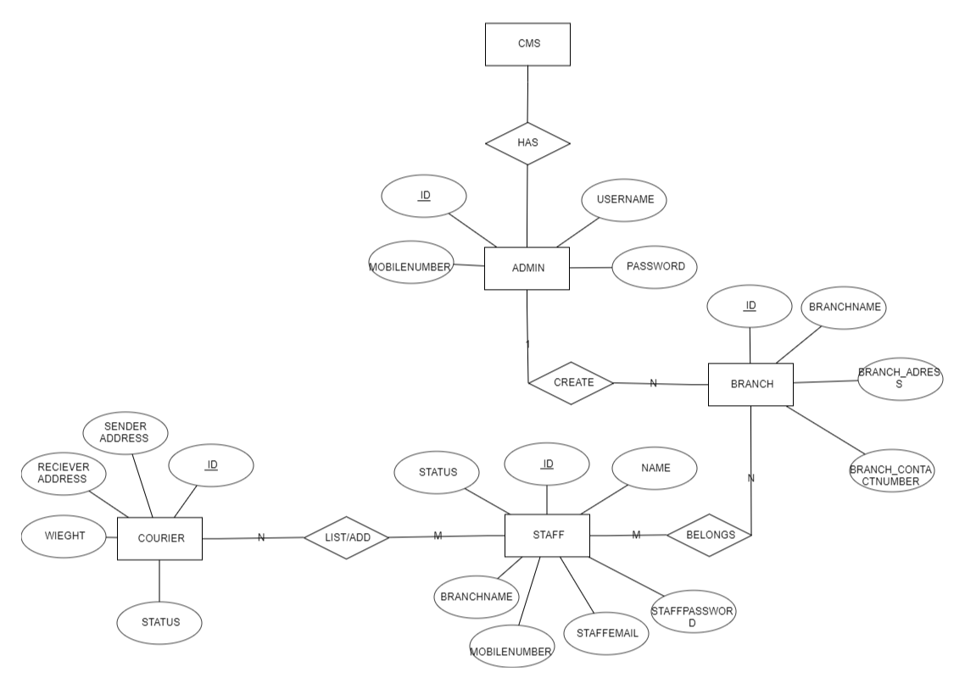

**Figure 3.1: E R diagram of Courier Management System**

* 1. **Schema Database Relationship Diagram**

A database schema is the skeleton structure that represents the logical view of the entire database. A database schema defines its entities and the relationship among them. It contains a descriptive detail of the data base, which can be depicted by means of schema diagrams.

#### 

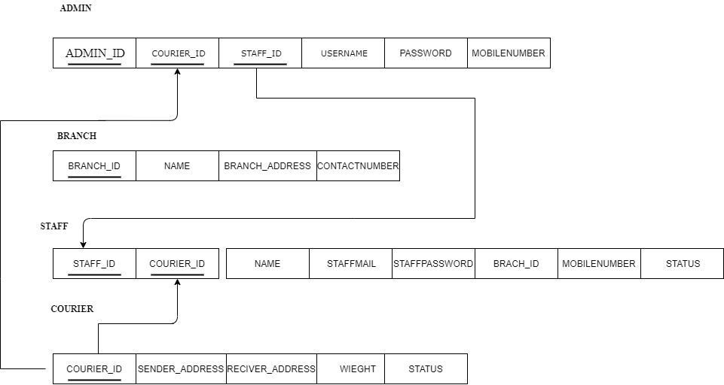

**Figure 3.2: Schema diagram Courier Management System**

**3.3 Overview of GUI**

The graphical user interface (GUI) is a form of user interface that allows users to interact with electronic devices through graphical icons and audio indicator such as primary notation, instead of text- based user interfaces, typed command labels or text navigation.

GUIs were introduced in reaction to the perceived steep learning curve of command- line interfaces (CLIs), which require commands to be typed on a computer keyboard. The graphic elements are windows, menus, icons, and links that are selected while working with a software application. The following buttons have been used in this

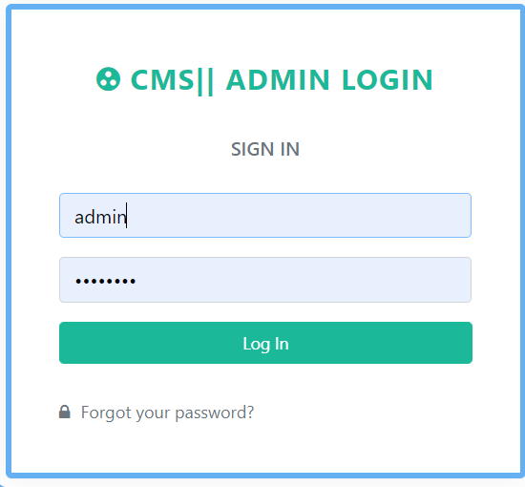

#### 

#### Fig 3.3 Login page

* 1. **Normalization**

Normalization is a process of analyzing the given relation schema based on their functional dependencies and primary key to achieve desirable properties of minimizing redundancy and minimizing insert, delete, update anomaly. The normalization process takes a relation schema through a series of tests to certify whether it satisfies a certain normal form. The normal form of a relation refers to the highest normal form condition that it meets, and hence the degree to which it has been normalized.

There are two goals of the normalization process: eliminating redundant data (for example, storing the same data in more than one table) and ensuring data dependencies make sense (only storing related data in a table). Both of these are worthy goals as it reduces the amount of space a database consumes and ensure that data is logically stored.

* + 1. **1NF (First Normal Form):**

1NF Rules:

-Each table cell should contain a single value.

-Each record needs to be unique The table below is in 1NF:

|  |  |  |  |  |  |  |
| --- | --- | --- | --- | --- | --- | --- |
| ID | Admin | UserName | Mobile_number | Password | Email | AdminRegdate |
| 1 | Admin | Abc | 1234567898 | 123456 | abcd@gmail.in | 2020-09-12 |
| 2 | Sadmin | admin | 987654321 | 09876 | sarith@gmail.in | 2010-03-12 |

#### Table 3.1 Member table in 1NF

* + 1. **2NF (Second Normal Form):**

2NF Rules:

-Should be in 1NF

-Single column primary key The table below is in 2NF:

It is clear that to move forward to make our simple database in 2nd Normalization form the table above needs to be partitioned:

(ID)🡪(Admin, UserName, Mobile_number, password, email, AdminRegdate)

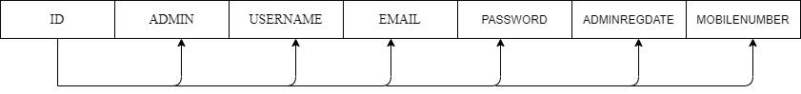

**3NF (Third Normal Form):**

3NF Rules:

-Should be in 2NF, no transitive dependency.

-Has transitive functional dependencies the table 3.1 is not in 3NF, therefore by decomposing:

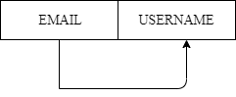

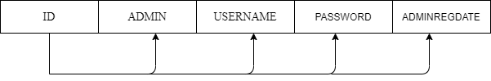



**CHAPTER 4**

COURIERMANAGEMENT SYSTEM

**IMPLEMENTATION**

* 1. **Table Creation**

**tbladmin:**

CREATE TABLE `tbladmin` (

`ID` int(11) NOT NULL,

`AdminName` varchar(50) DEFAULT NULL,

`UserName` varchar(50) DEFAULT NULL,

`MobileNumber` bigint(10) DEFAULT NULL,

`Email` varchar(120) DEFAULT NULL,

`Password` varchar(120) DEFAULT NULL,

`AdminRegdate` timestamp NULL DEFAULT CUR;

#### tablecourier:

CREATE TABLE `tblcourier` (

`ID` int(11) NOT NULL,

`RefNumber` varchar(120) DEFAULT NULL,

`SenderBranch` varchar(120) DEFAULT NULL,

`SenderName` varchar(120) DEFAULT NULL,

`SenderContactnumber` bigint(11) DEFAULT NULL,

SenderAddress` varchar(120) DEFAULT NULL,

`SenderCity` varchar(120) DEFAULT NULL,

`SenderState` varchar(120) DEFAULT NULL,

`SenderPincode` varchar(120) DEFAULT NULL,

`SenderCountry` varchar(120) DEFAULT NULL,

`RecipientName` varchar(120) DEFAULT NULL,

`RecipientContactnumber` bigint(11) DEFAULT NULL,

`RecipientAddress` varchar(120) DEFAULT NULL,

`RecipientCity` varchar(120) DEFAULT NULL,

`RecipientState` varchar(120) DEFAULT NULL,

`RecipientPincode` varchar(120) DEFAULT NULL,

**Courier Management System**

`RecipientCountry` varchar(120) DEFAULT NULL,

` CourierDes` varchar(250) DEFAULT NULL,

`ParcelWeight` varchar(120) DEFAULT NULL,

`ParcelDimensionlen` varchar(120) DEFAULT NULL,

`ParcelDimensionwidth` varchar(120) DEFAULT NULL,

`ParcelDimensionheight` varchar(120) DEFAULT NULL,

`ParcelPrice` varchar(120) DEFAULT NULL,

`Status` varchar(124) DEFAULT NULL,

`CourierDate` timestamp NOT NULL DEFAULT CURRENT_TIMESTAMP)

#### tblcouriertracking:

CREATE TABLE `tblcouriertracking` (

`ID` int(11) NOT NULL,

`CourierId` int(11) DEFAULT NULL,

`remark` mediumtext,

`status` varchar(255) DEFAULT NULL,

`StatusDate` timestamp NULL DEFAULT CURRENT_TIMESTAMP)

#### tblstaff:

CREATE TABLE `tblstaff` (

`ID` int(10) NOT NULL,

`BranchName` varchar(120) DEFAULT NULL,

`StaffName` varchar(120) DEFAULT NULL,

`StaffMobilenumber` bigint(11) DEFAULT NULL,

`StaffEmail` varchar(120) DEFAULT NULL,

`StaffPassword` varchar(120) DEFAULT NULL,

`StaffRegdate` timestamp NOT NULL DEFAULT CURRENT_TIMESTAMP,`status` int(1) DEFAULT NULL

#### tblbranch:

#### CREATE TABLE `tblbranch` (

#### `ID` int(11) NOT NULL,

#### `BranchName` varchar(120) DEFAULT NULL,

#### `BranchContactnumber` bigint(11) DEFAULT NULL,

#### `BranchEmail` varchar(120) DEFAULT NULL,

#### `BranchAddress` varchar(120) DEFAULT NULL,

#### `BranchCity` varchar(120) DEFAULT NULL,

#### `BranchState` varchar(120) DEFAULT NULL,

#### `BranchPincode` varchar(120) DEFAULT NULL,

#### `BranchCountry` varchar(120) DEFAULT NULL

## 4.2Description of Tables

#### tbladmin :

DESC tbladmin;

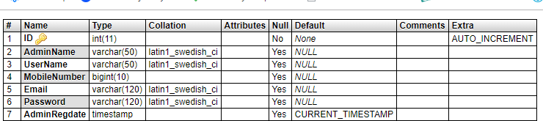

#### Fig 4.1 Admin login Description

**tblbranch:**

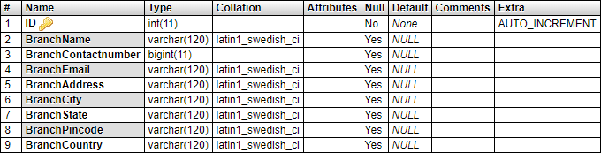DESC branch;

#### Fig 4.2 branch Description

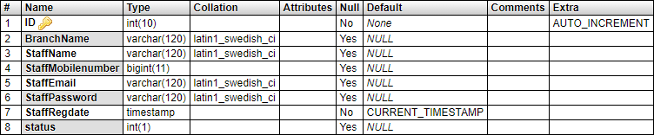DESC staff;

#### Fig 4.3 staff Description

**tblcourier:**

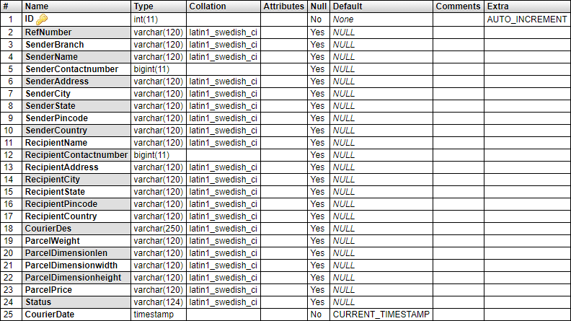DESC courier;

#### Fig 4.4 courier Description

**Tblcouriertracking;**

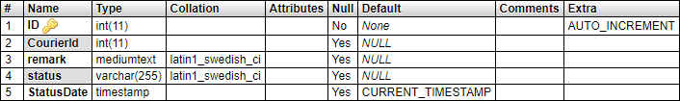DESC couriertracking:

#### Fig 4.5 couriertracking Description

**4.2 Populated Tables**

SELECT * FROM tbladmin;



#### Fig 4.6 Admin login Data

SELECT * FROM tblbranch;

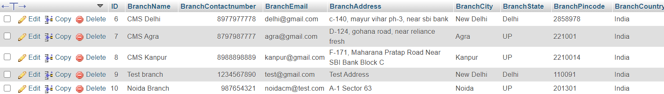

#### Fig 4.7 branch Data

SELECT * FROM courier Data;

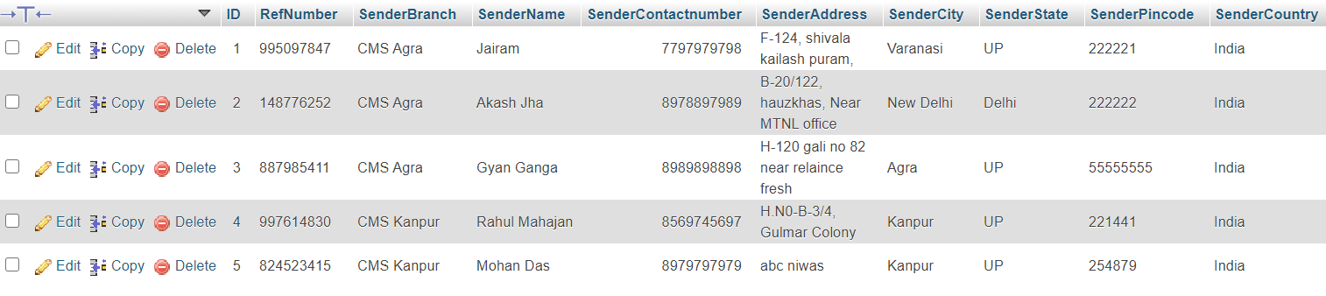

#### Fig 4.8 courier Data

SELECT * FROM tblcouriertracking;

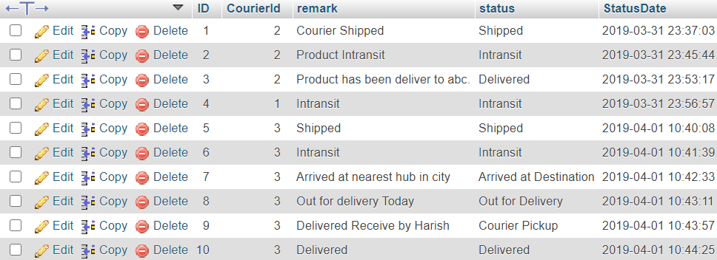

#### Fig 4.9 couriertracking Data

SELECT * FROM tblstaff;



#### Fig 4.10 staff Data

**Database connectivity**

The front end can be easily connected to the back end (i.e. MySQL) by adding a few instructions in PHP. The following instructions are to be added.

<?php

//establishing connection to the database using php using the database //name (i.e. cms)

$con=mysqli_connect (“localhost”,” root”,””,”cms”);

//Check if the connection has been established otherwise print the message failed to

//establish connection to MySql

if ($con)

{

echo “Connection Successful”;

}

else

{

echo “Connection could not be established”;

}

?>

**CHAPTER 5**

COURIERMANAGEMENT SYSTEM

1. **HOME PAGE**

**RESULTS**

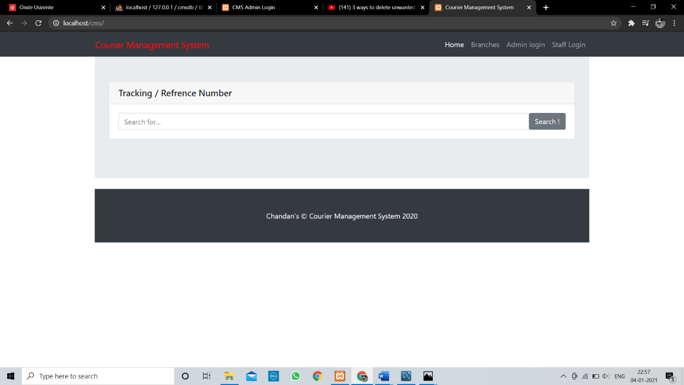

Fig 5.1 – Home page

**2.BRANCH DETAILS:**

The user can check about company branches.

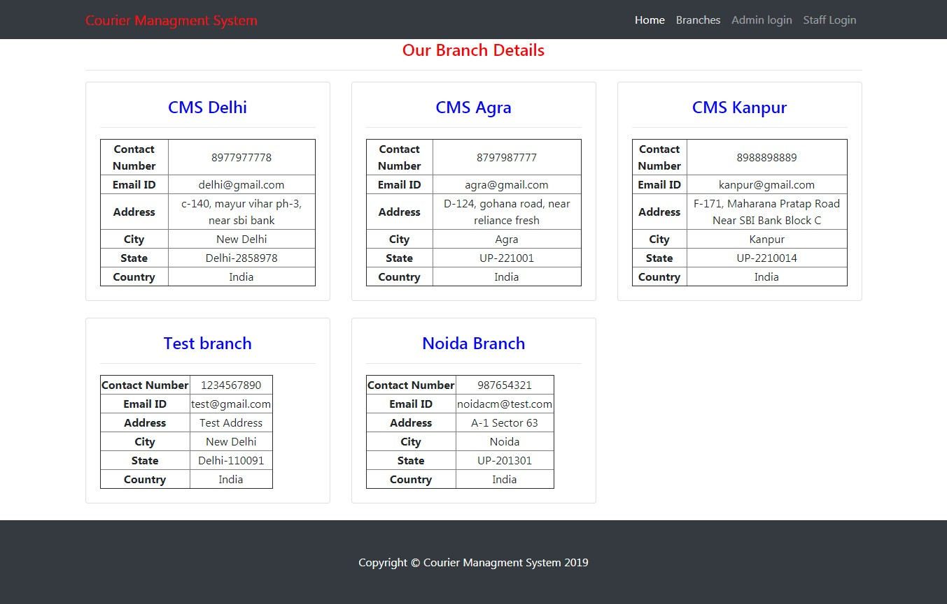

Fig 5.2 – Branch Details

#### 

**2.ADMIN LOGIN:**

Admin should login with his/her username and password.

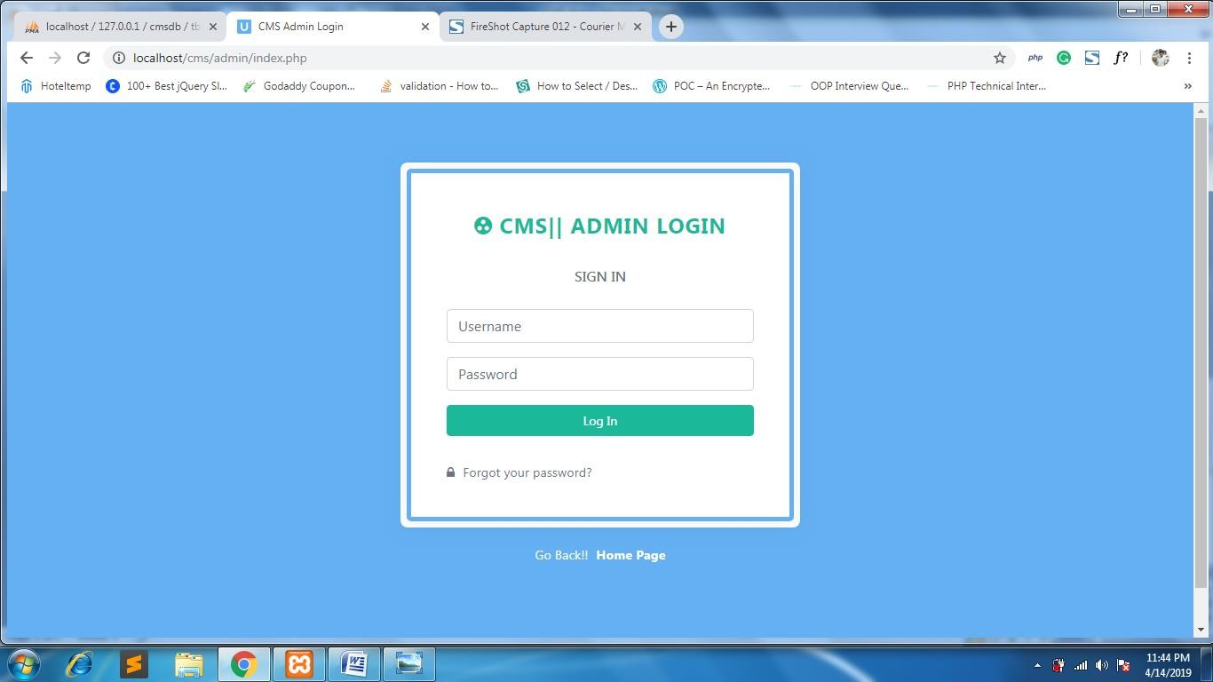

Fig 5.3 – Admin login

#### 

**3.ADMIN DASHBOARD:**

After login admin is take to the admin dashboard.

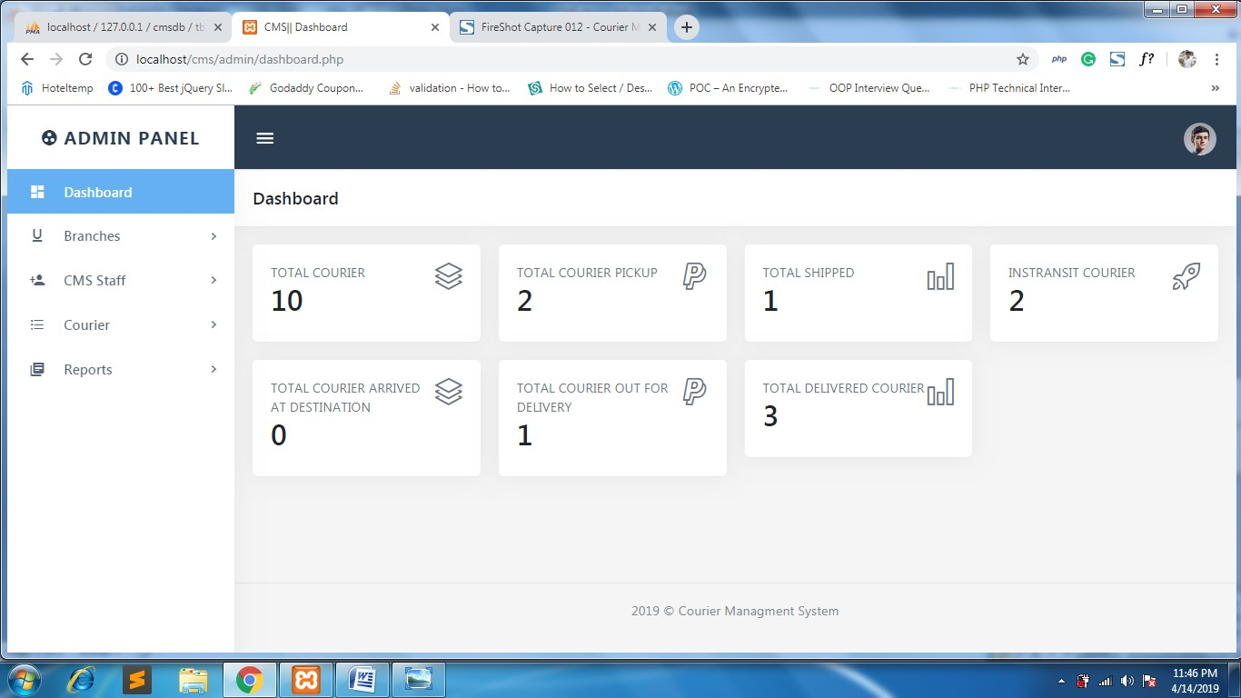

Fig 5.4 – Admin Dashboard

**2.ADD BRANCH:**

Where admin have access to add a new branches.

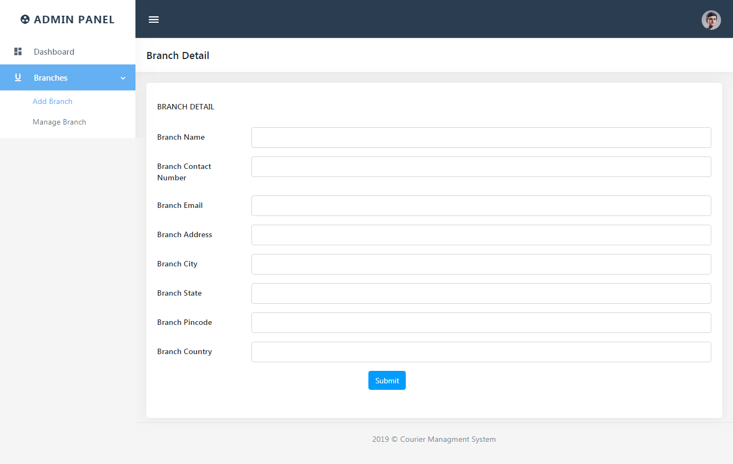

#### 

Fig 5.5– Add Branch

**3.MANAGE BRANCH PAGE:**

Admin can manage all the branch details.

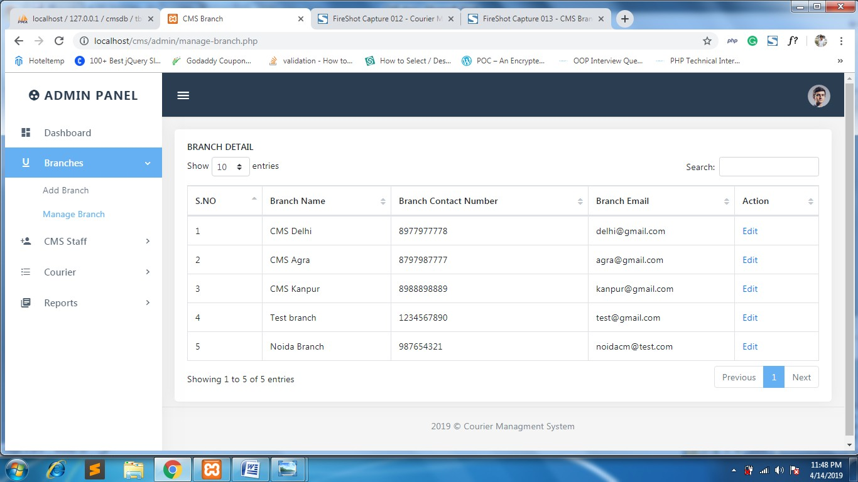

Fig 5.6 – Manage branch

#### 

**5.EDIT BRANCH DETAILS:**

Admin can edit or manage the branch details.

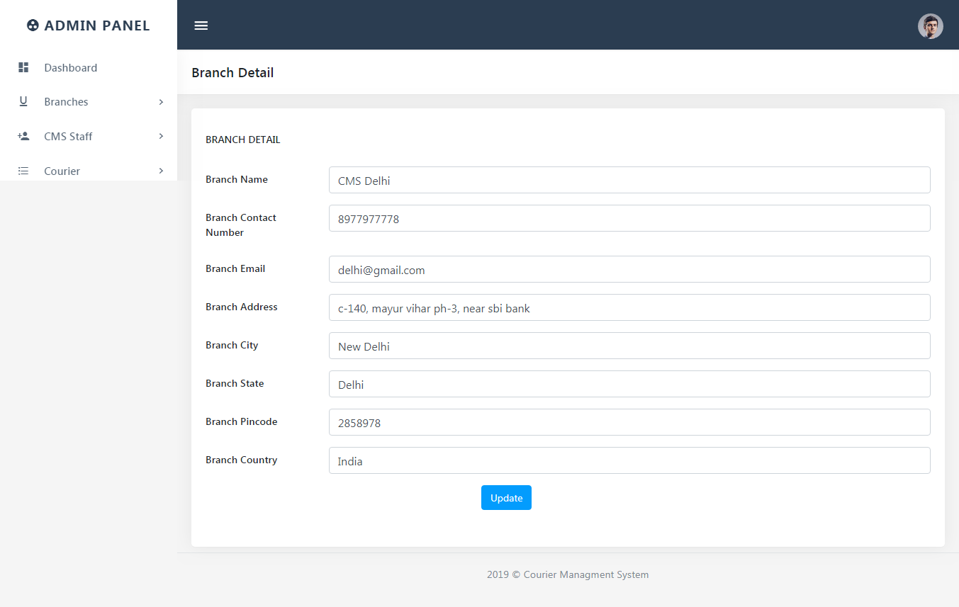

Fig 5.7 – Edit branch Detail

#### 

**ADD STAFF:**

Admin have a access to add a new staff by entering details.

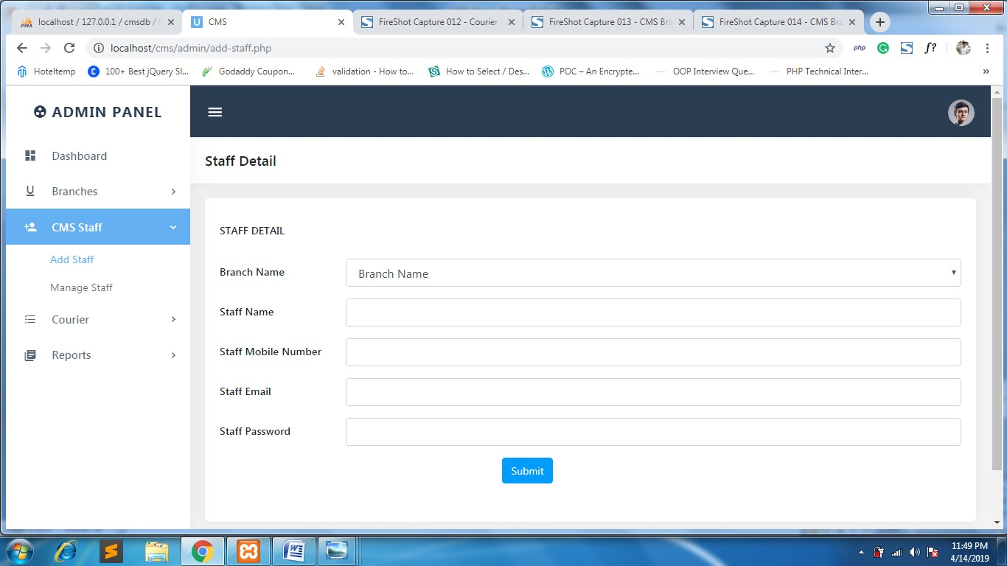

Fig 5.8– Add staff

**7.MANAGE STAFF:**

Admin can manages the staff.

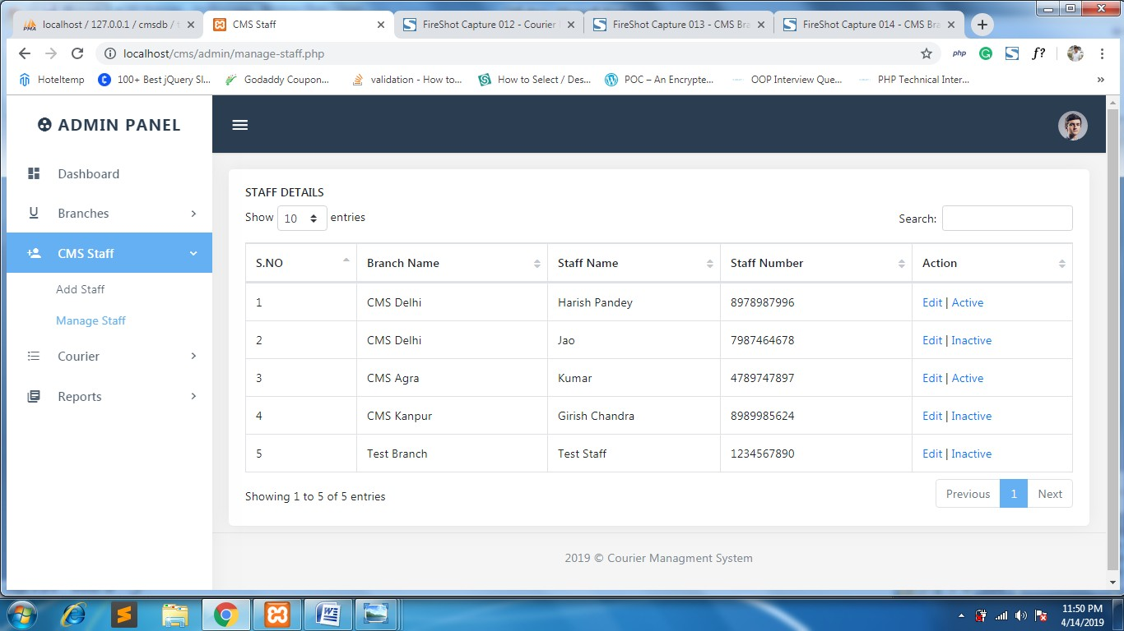

Fig 5.9 – Manage staff

#### 

**10.EDIT STAFF DETAILS:**

Admin can edit the staff detail.

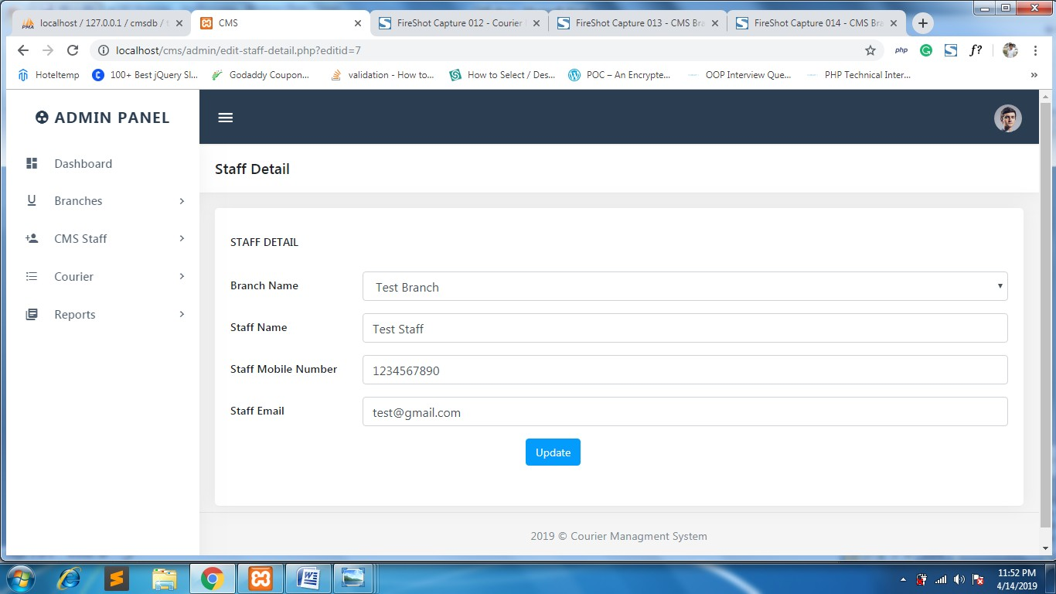

Fig 5.10 – Edit staff Details

**11.MANAGE COURIER:**

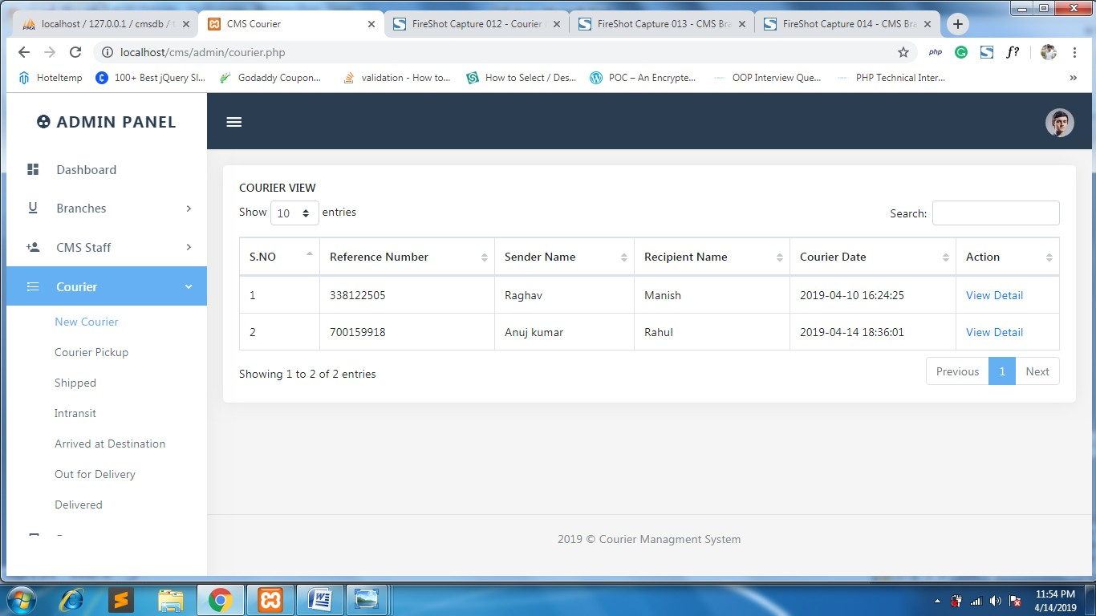

Fig 5.11 – Manage courier

**12.VIEW COURIER DETAILS:**

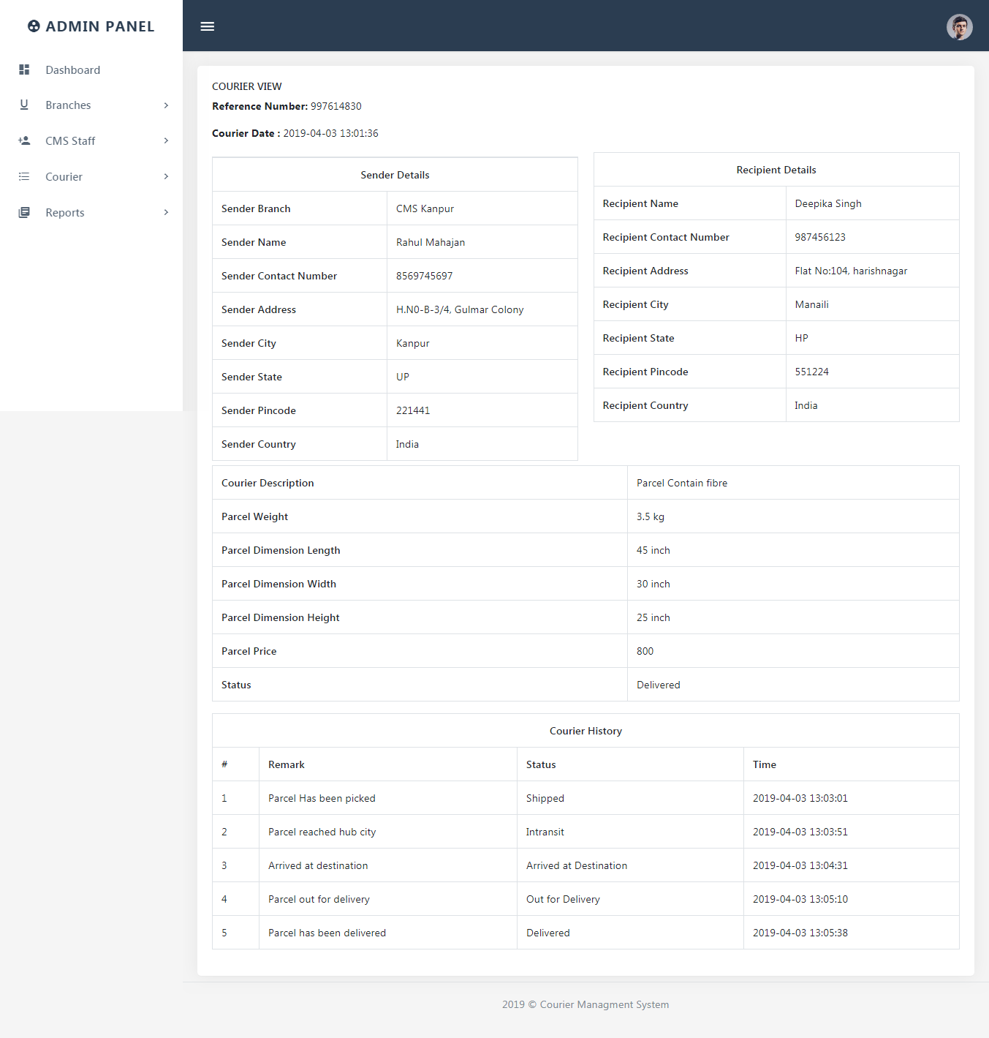

Fig 5.12 – View Courier

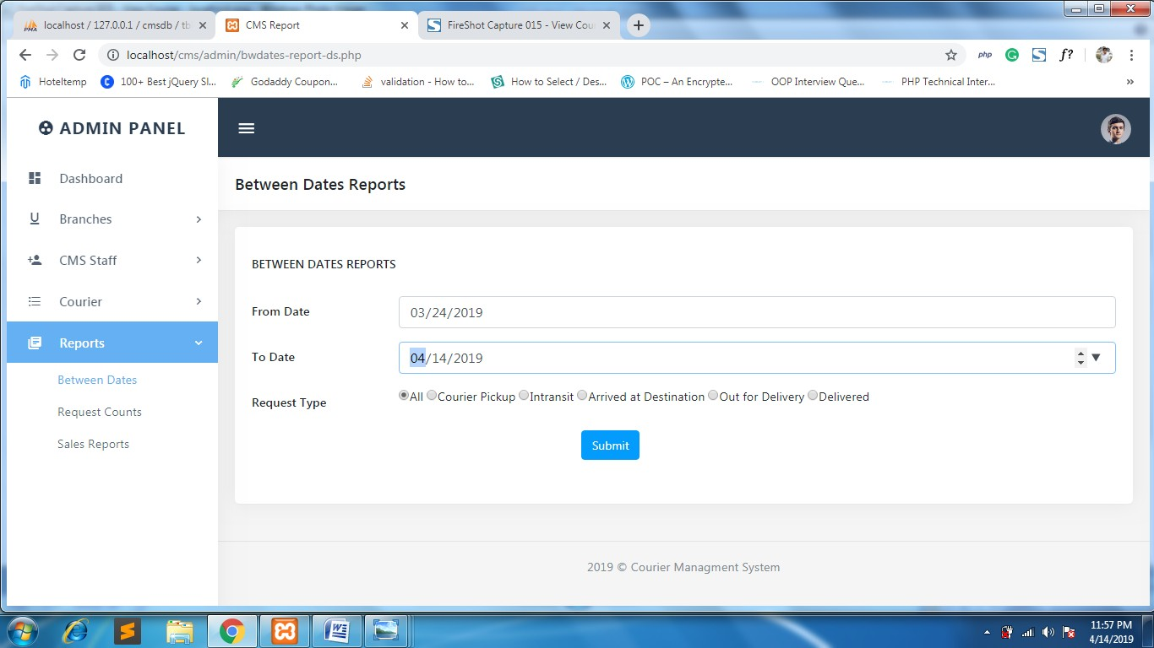**13.BETWEEN DATE REPORT AND DETAILS:**

Fig 5.13(a) – Between date report searchin

**14.COURIER COUNT REPORT**

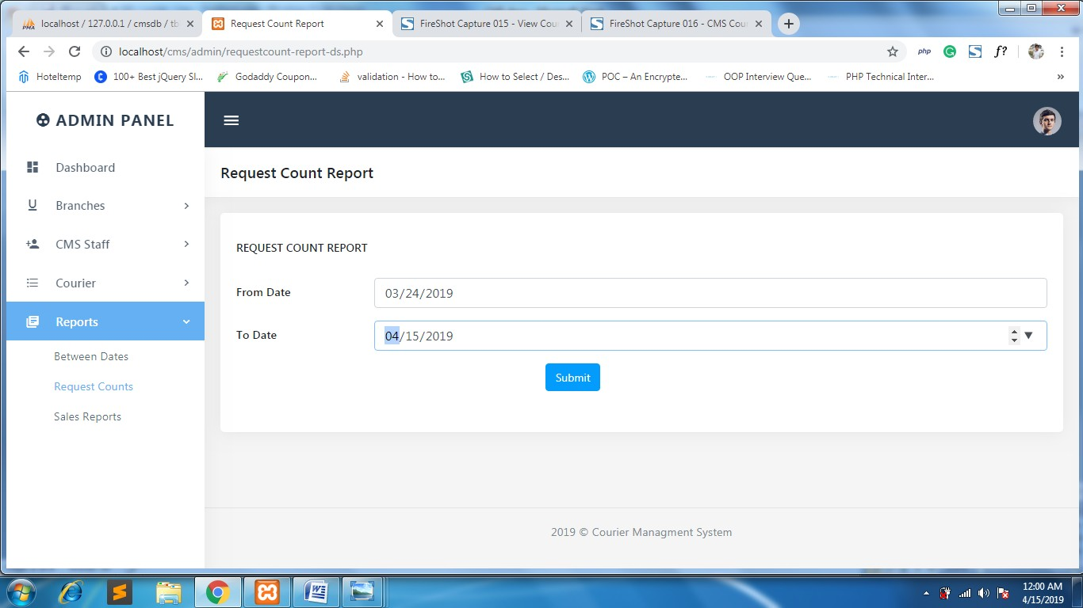

Fig 5.14– Courier count report

**15.REQUEST COUNT REPORT:**

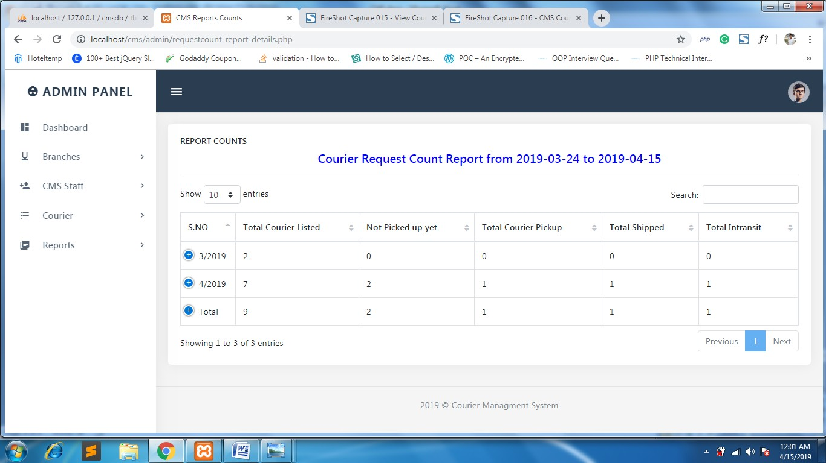

Fig 5.15 – Request count report

**16.SALES REPORT:**

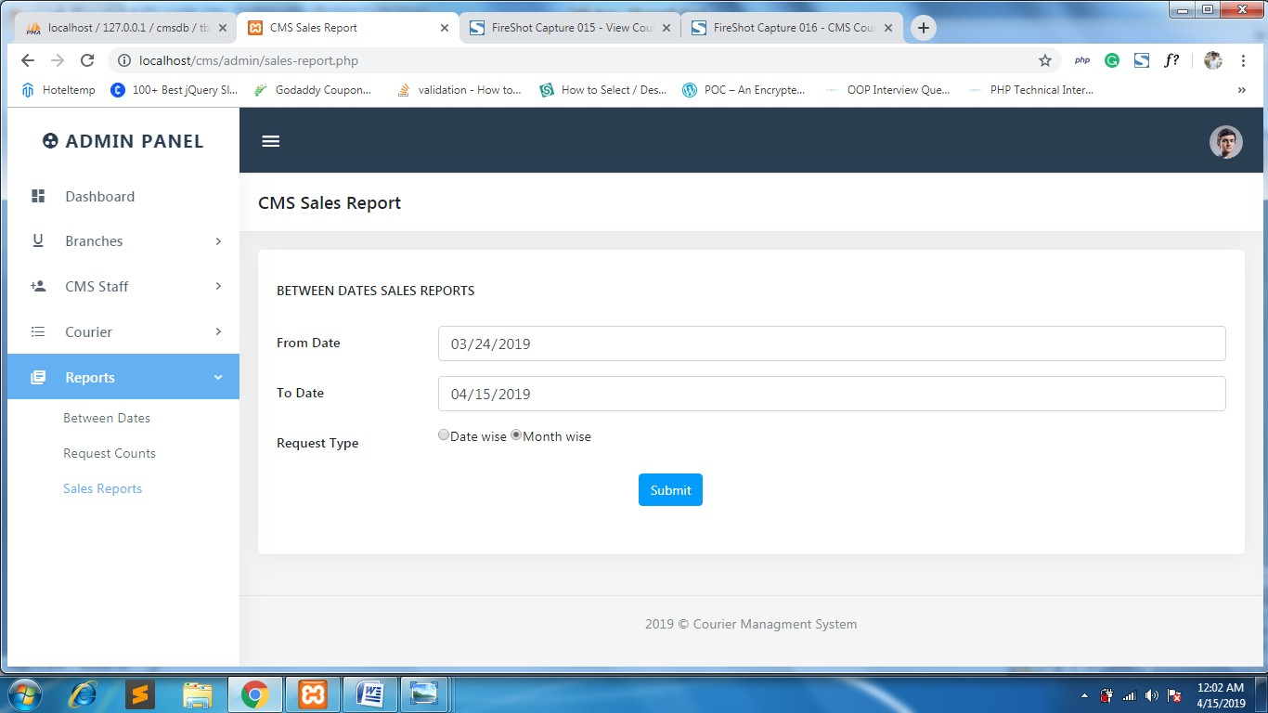

Fig 5.16 – Sales Report

**17.SALES REPORT DEATAILS:**

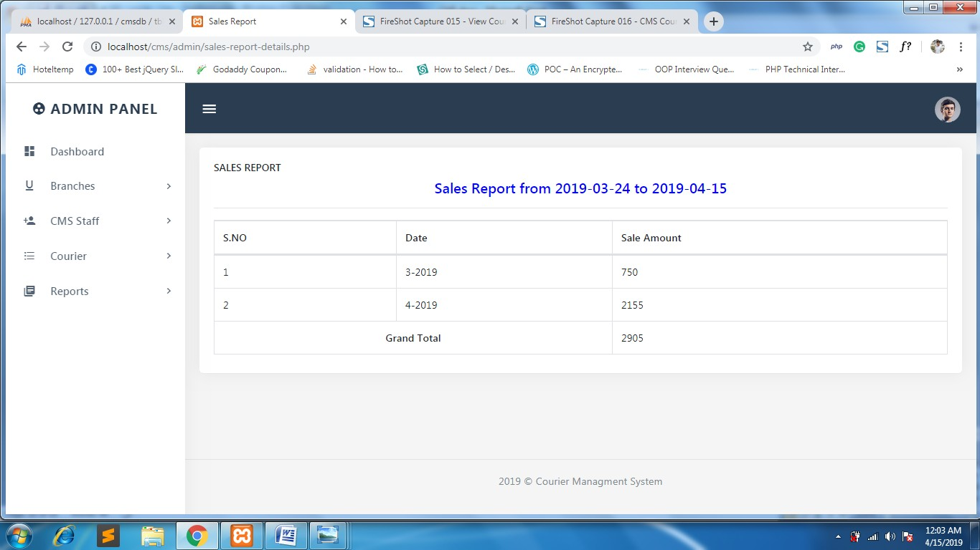

Fig 5.17 – Sales Report Details

**18. ADMIN PROFILE:**

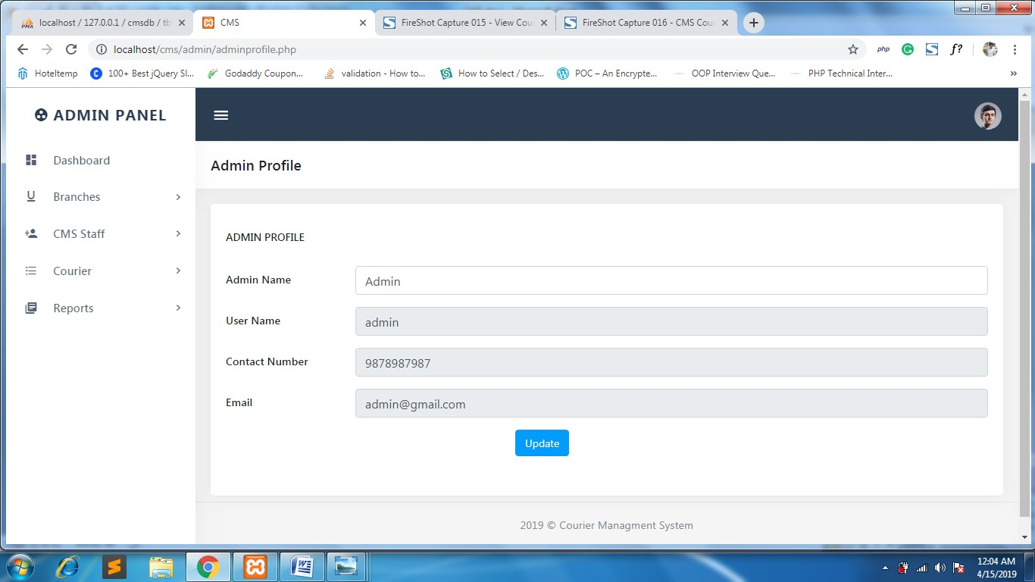

Fig 5.18 – Admin Profile

**19. CHANGE PASSWORD :**

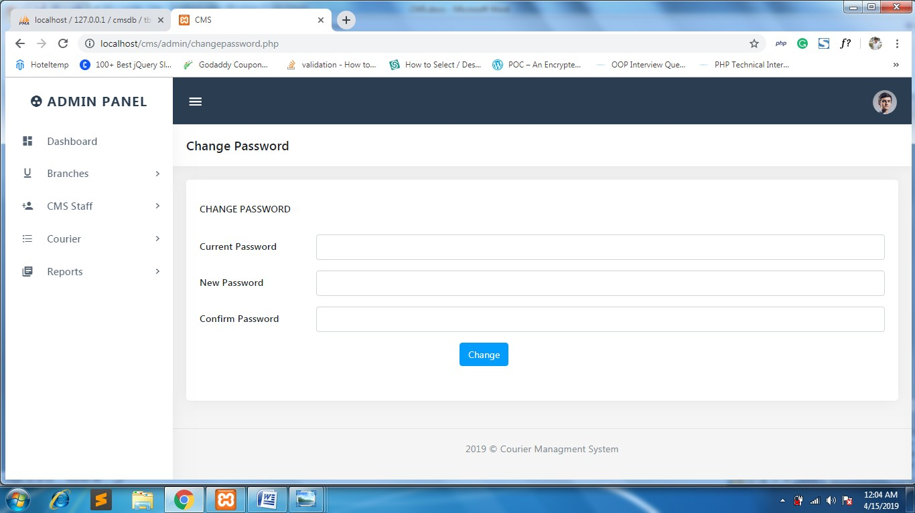

Fig 5.19 – change password

**20. ADMIN FORGOT PASSWORD:**

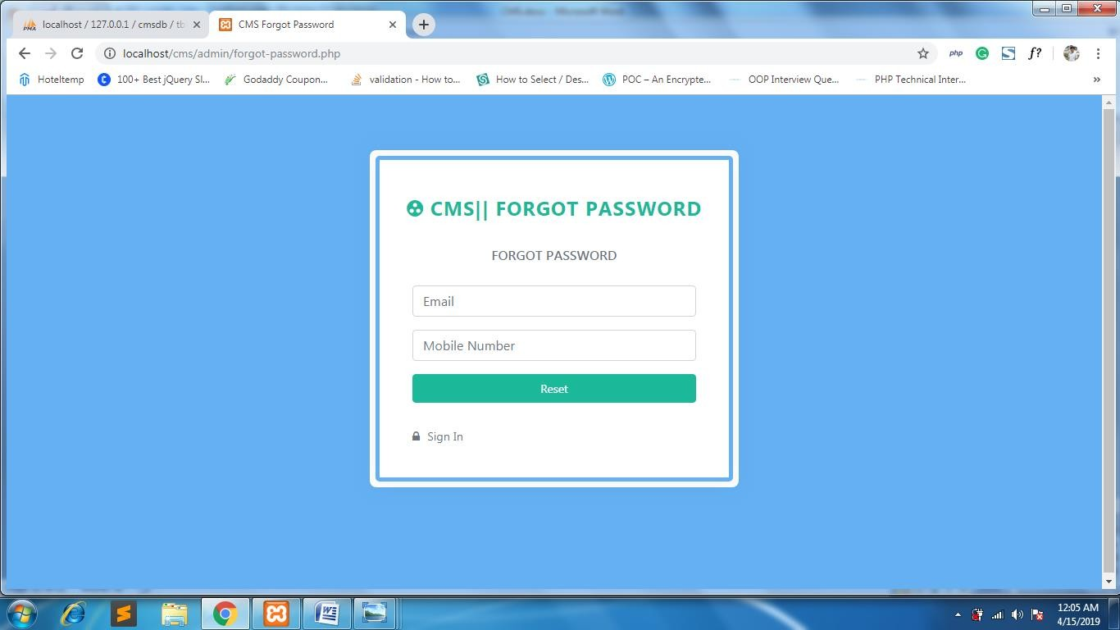

Fig 5.20 – Admin Forgot Password

**21.ADMIN RESET PASSWORD:**

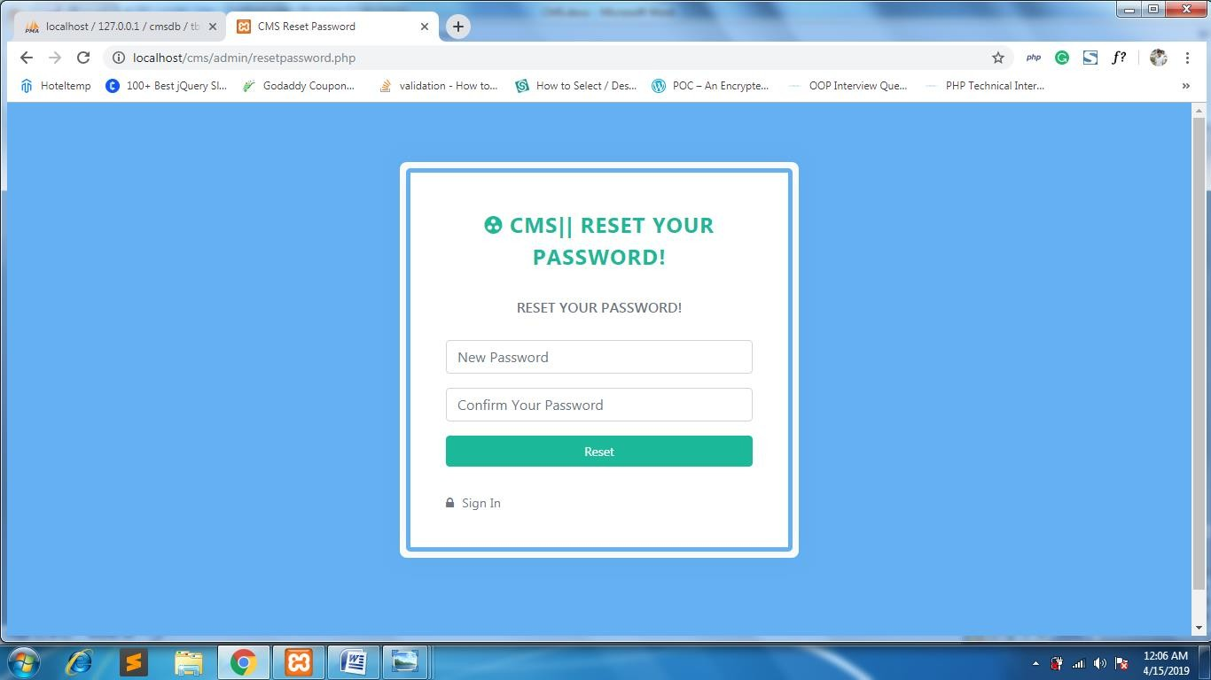

Fig 5.21 – Admin reset password

**22.STAFF DASHBOARD:**

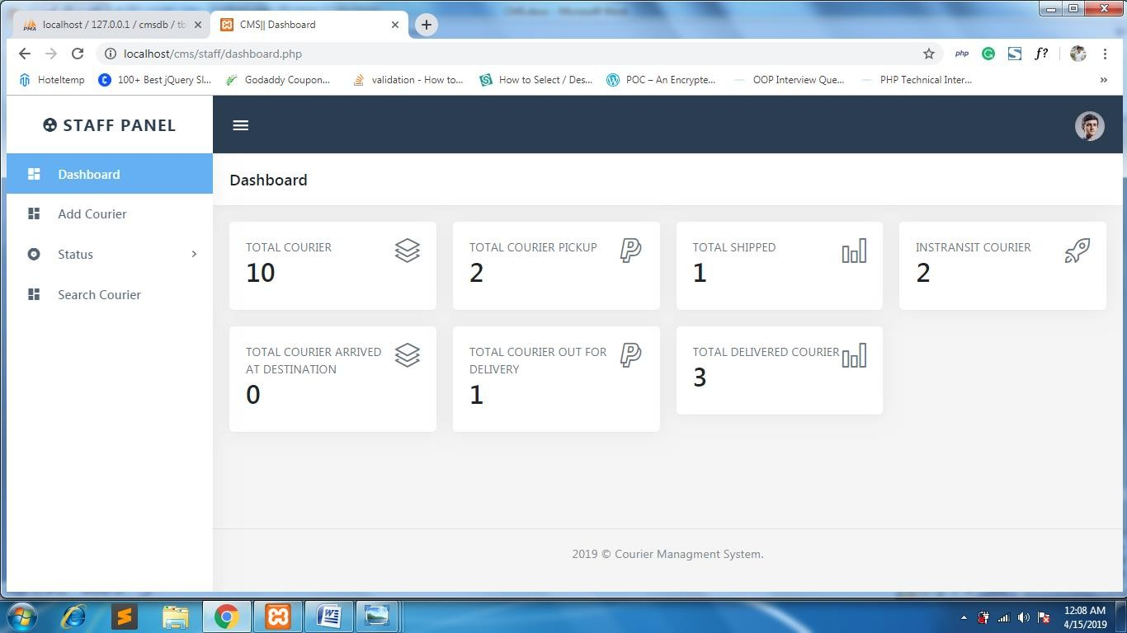

Fig 5.22 – staff dashboard

**23. COURIER DETAILS FORM:**

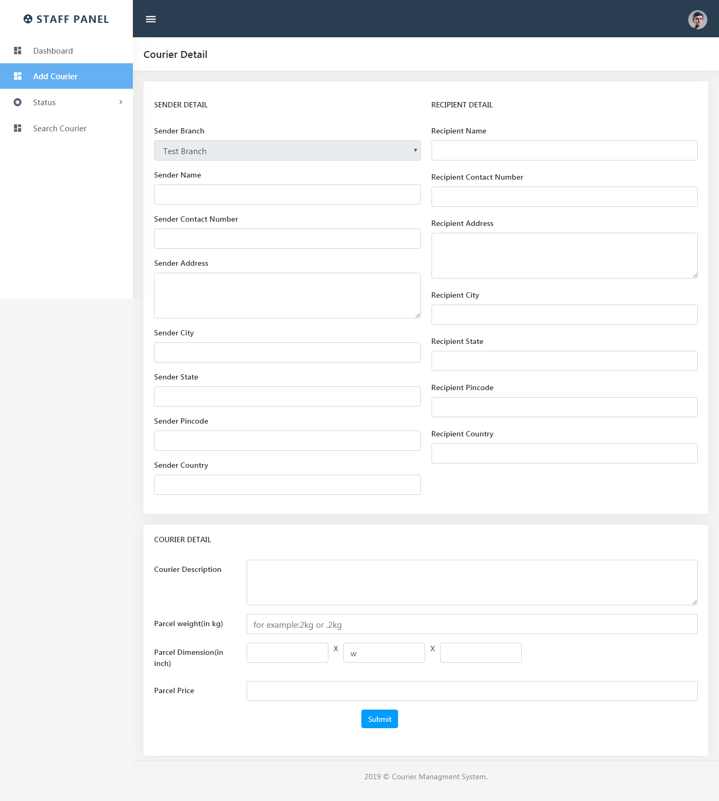

Fig 5.23 – Courier details form

**24.MANAGE COURIER :**

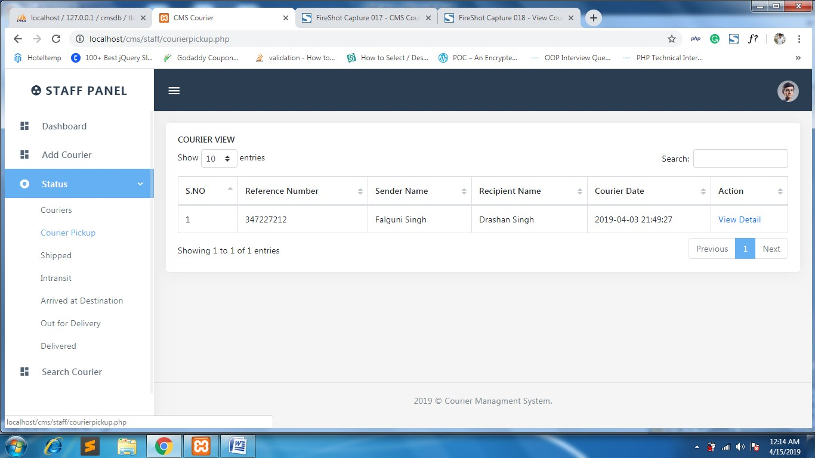

Fig 5.24 – Manage Courier

**25. VIEW COURIER :**

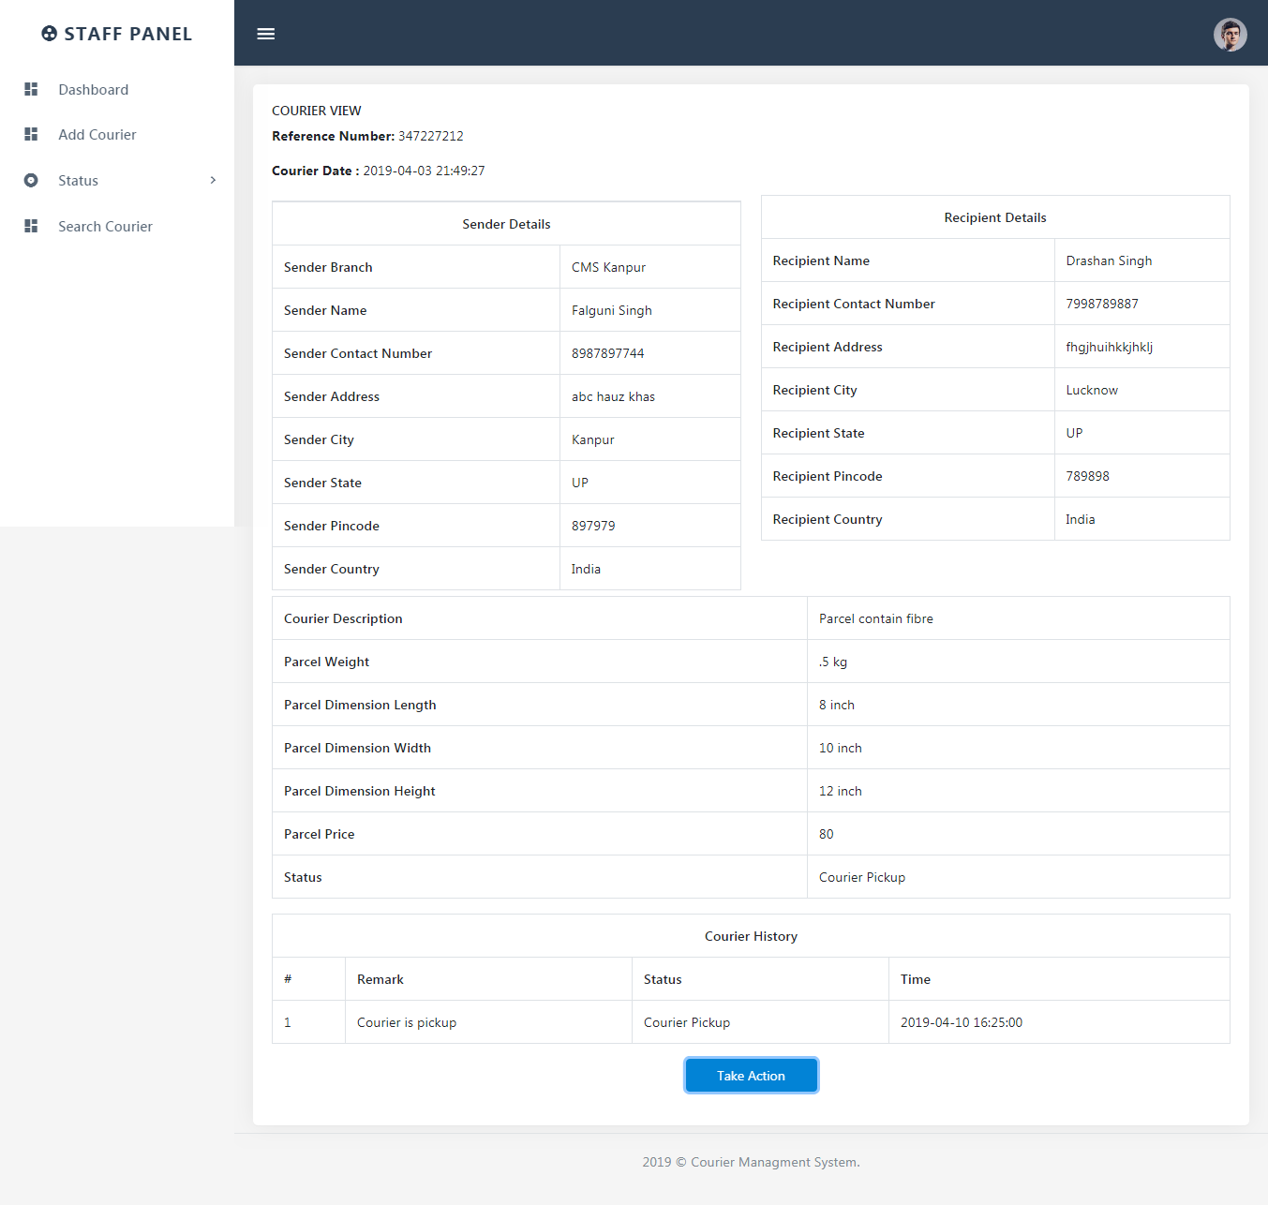

Fig 5.25 – view courier details

**COURIER ACTION :**

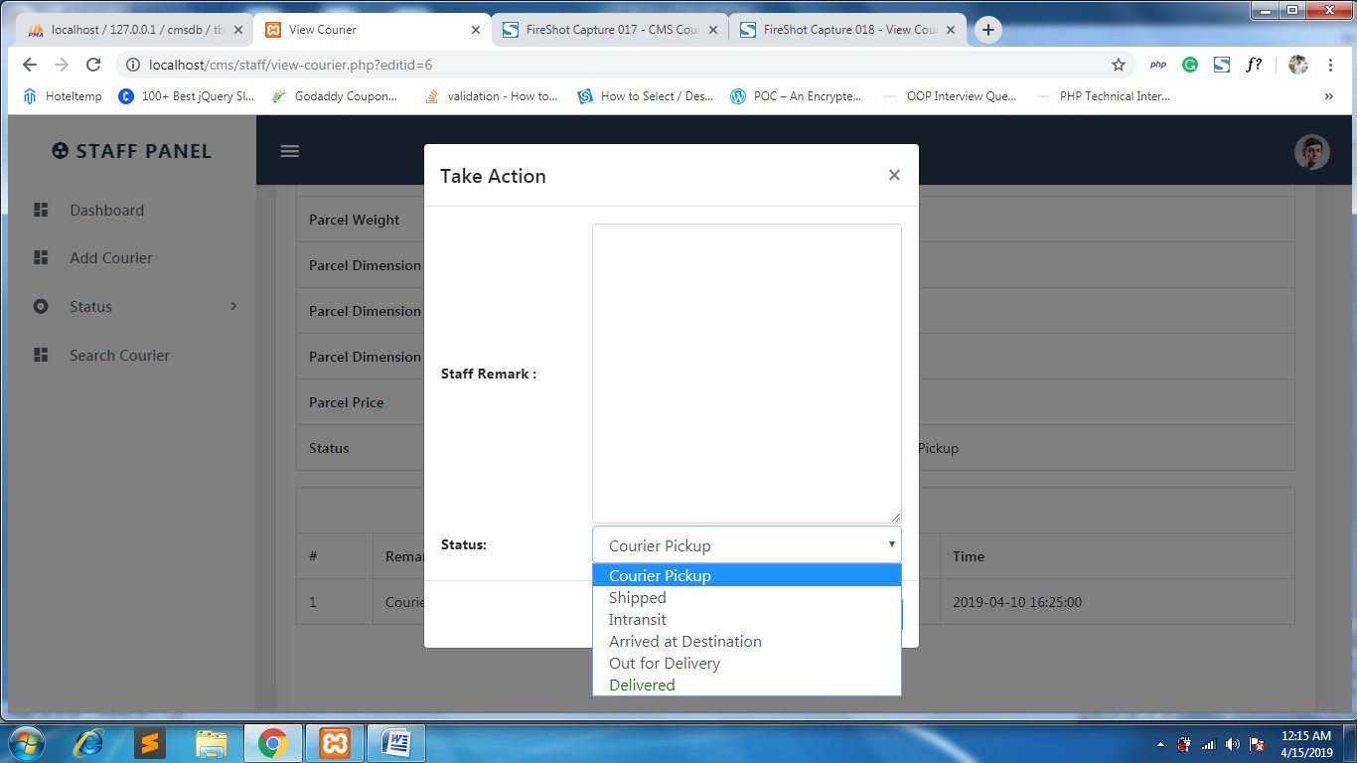

Fig 5.26 – Courier Action

**27. SEARCH PAGE :**

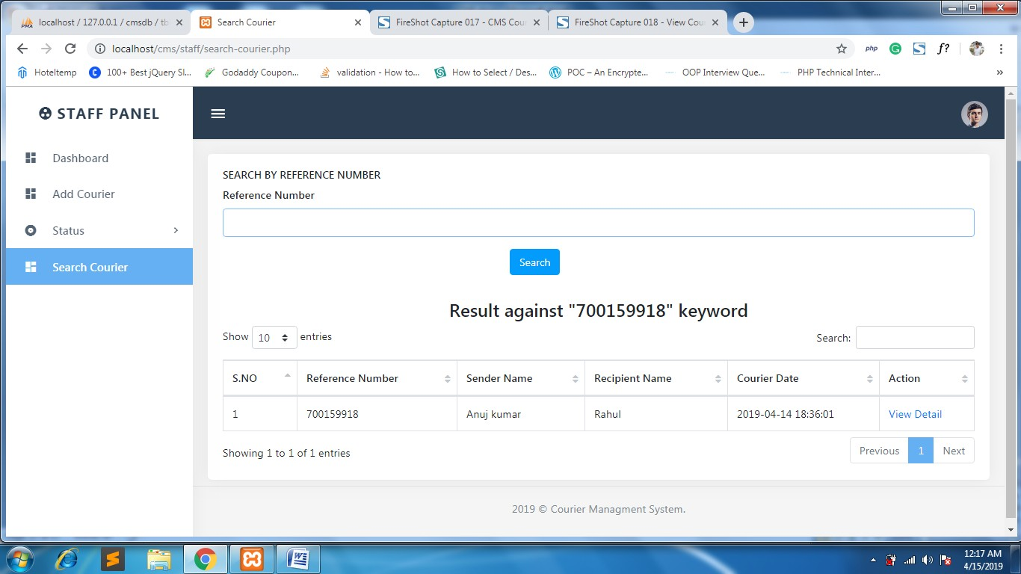

Fig 5.27 – Search Page

**28.STAFF PROFILE:**

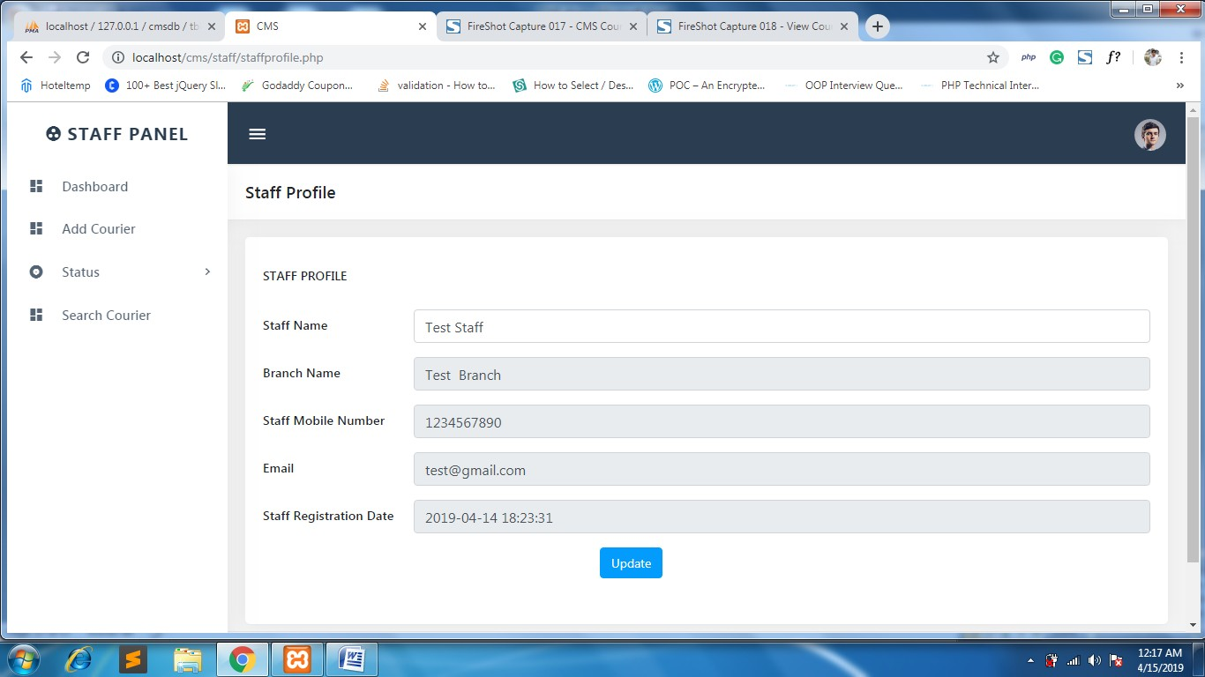

Fig 5.28 – Staff profile

**CONCLUSION**

This project will replace the traditional way of courier distribution. The couriers distributed in a manual fashion and that can be replaced by faster and more effective system. This platform eliminates this problem as it saves the data online and it reduces the redundancy. This project has very high potential to grow in future. While implementing this project we came to know the real-world problems and found a solution to the problem. During this project we learned about the basic Database Management System and how to implement it for real world problems.To implement the idea behind the project we also learned basic JSP for back- end development and HTML and CSS for front-end development. we now feel quite confident in the mentioned languages and can implement other projects using these languages.

Courier Management System which supports the high accessibility of courier services to the corporate and to the customer. The system is being used for day to day activities such as booking a courier, maintain hub details, maintain company details, process data of businesses and many other things.Courier management computerization is “the incorporation of appropriate technology to help manager manage information. Technology is considered suitable when it utilizes the most abundant domestic possessions and conserves investment and skilled personnel”

# FUTURE ENHANCEMENT

In a nutshell, it can be summarized that the future scope of the project circles around maintaining information regarding:

* + - Integrate the system into now evolving e-commerce industries.
    - Develop advance software for Courier Management System.
    - Host the platform on online servers to make it accessible worldwide.
    - Integrate Multiple load balancers to distribute the loads of the system.
    - Implement a notification system via SMS to notify customer about the order.
    - Implement the backup mechanism for taking backup of codebase and database on regular basis on different servers.